I live in the mountains north of LA and have been using solar panels to heat my pool since I installed it in 2005. The panels are starting to fail, one at a time, and I need to replace them.
The information on my location:
Latitude: 34° 49. Longitude: 119° 1’. Elevation: 5400 ft. (1646 meters) above sea level
The pool is approximately 40’x20’, 800 sq.ft. (12m x 6m, 74 sq.meters)
The panels I currently use are on a hill side with approximately 20° slope and are situated at 44° True North (30° Magnetic North).
They have been keeping my pool at about 90° F during the summer (32° C). I’d like to be able to have a system which maintains this temperature.
We do keep the pool covered with a solar blanket, since the temperatures can drop pretty low at night in our area.
Since I have the panels on the ground I could reconfigure the new panels to optimize for maximum sunlight exposure.
What system would you recommend to replace my current solar heating system? My system is already configured with a Goldline controller, automatic valve, and pump for the system.
Here is a photo of the panels (20’ x 10’ = 200 sq.ft, approximately 18 sq.meters)
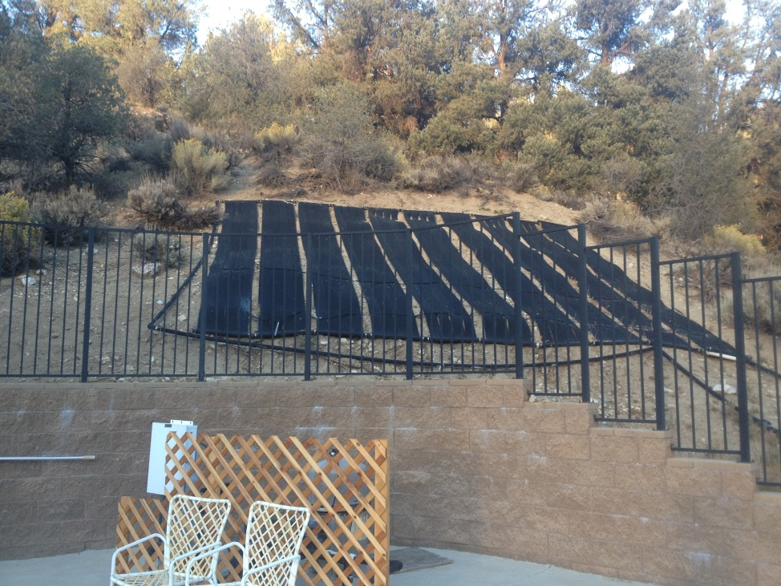
Here is a photo of the pool with the pool covered.
